Group B Case Study: Outland Adventures
Modifications Made
Michael Gordon, Michael Benko, Jacob Richman
Bellevue University
Database Development and Use CSD310
Professor: Dr. Mortoza Abdullah
10/11/2026

Contents
Python Code modifications: 2
Python Code modifications: 2
Revised Python Output: 5
Revised Graph: 7
PowerPoint revisions: 9

Python Code modifications:
Based on the Module 11.1 Case Study critiques, we realized that report 1, which was supposed to answer the question, “Do enough customers buy equipment to keep equipment sales?”, did not answer it because it looked at sales by customer rather than by item sold. The Python code for equipment sales has been modified to accurately reflect sales against a goal number that the company can modify at will.

We also decided to evaluate the condition of any equipment over the 5-year mark. This provides the company with much more useful information for assessing replacement needs and costs.

Equipment Sales Python Code
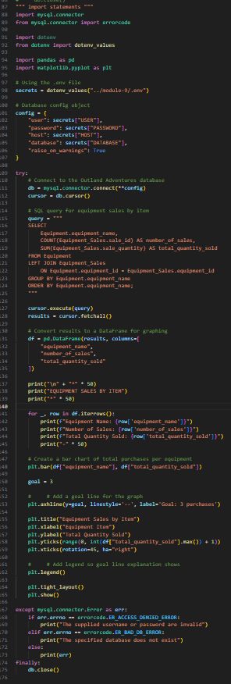

Equipment Condition Python Code
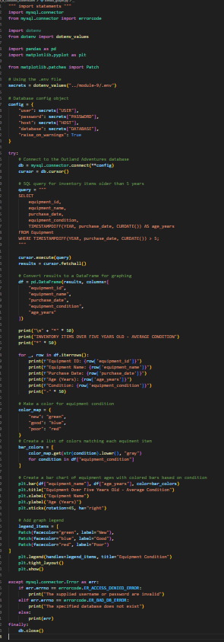

Revised Python Output:
Equipment Sales
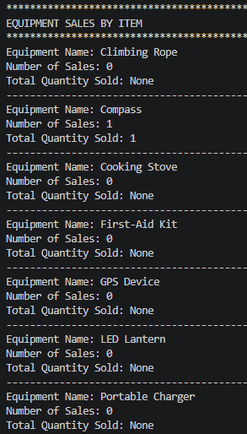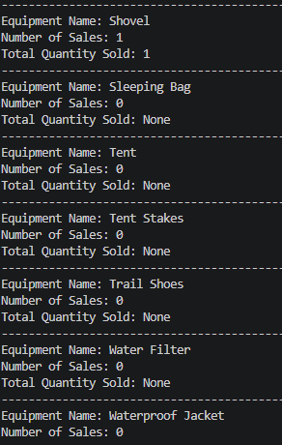

Equipment Condition
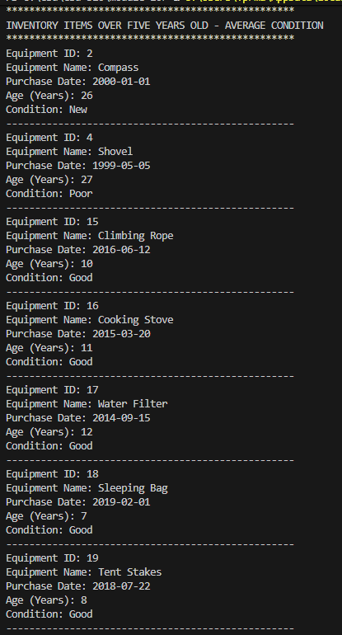

Revised Graph:
Equipment Sales
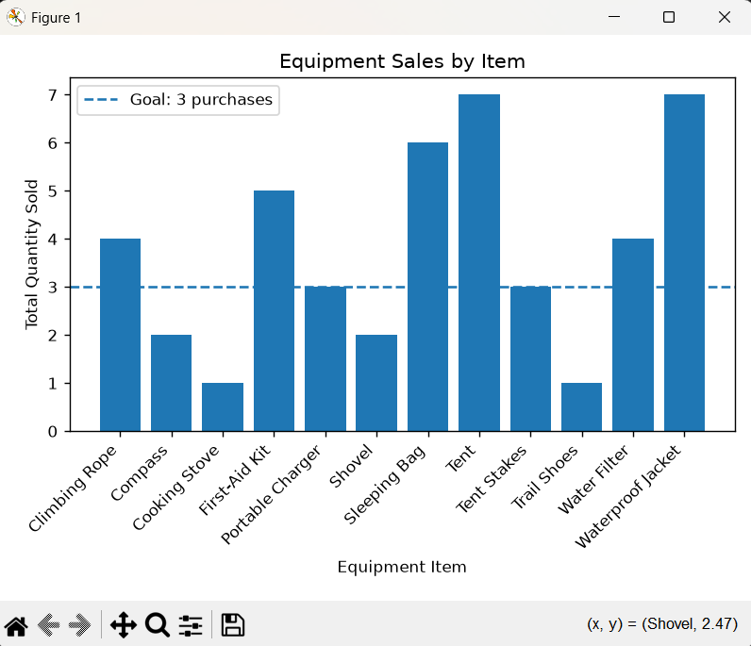

Equipment Condition
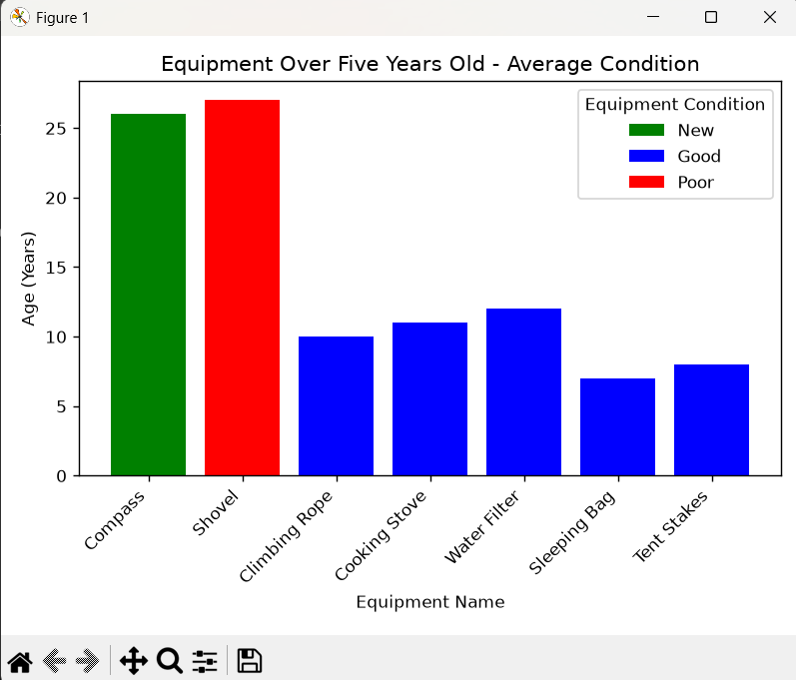

PowerPoint revisions:
- The font for the presentation was changed to remove all Caps. This change made the slides more professional and easier to read.
- Background transparency was increased for some slides to increase the contrast between the background and the text, making reading easier.
- Slide 5 text was edited to reflect the shift from the customer-focused report to the equipment-focused report.
- Slide 6 text was edited to reflect the shift from the customer-focused report to the equipment-focused report. The new Python report output replaced the customer-focused output.
- Slide 7 text was edited to reflect the shift from the customer-focused report to the equipment-focused report. The new graph replaced the customer-focused graph.
- Slide 14 text was edited to show that sales are not a meaningful revenue stream.
- Slide 15 text (the missing data bullet) was edited to reflect the change from the customer-focused report to the equipment-focused report.

